Adult Swim Lesson FAQ/SOP

Check the RecSports website and/or email RSAquatics@ufsa.ufl.edu

When can you register for swim lessons?
- You can begin registering for swim lessons two-four weeks before they start on the RecSports website. Spots fill up quickly, so to secure a spot we encourage you to register as early as possible.
How long are lessons?
- Lessons are 45 minutes in length. Each session has four lessons over four weeks.
How often do we host swim lessons?
- We offer between 2-3 sessions every semester. Check the RecSports website.
Do we provide youth lessons?
- We do offer youth swim lessons. Check the RecSports website for dates and registration.
Do we provide private lessons?
- We do not provide private lessons currently. But check the RecSports website in the future for updates.
Can youths sign up for adult lessons?
- No, we are only able to teach folks that are over 18.
Can a participant sign up for multiple time slots?
- Technically yes, but we encourage them to just register for one because of the limitations of the space and our goal of serving as many people as possible. Extenuating services permitted.
How many instructors are there?
- We have one instructor for every six participants.
What are the qualifications for the instructors?
- All UF instructors are required to be Red Cross certified Water Safety Instructors. They have passed a teaching course, they are swimmers, and they all have experience teaching.

If I am a beginner, can I register for Intermediate/advanced?
- No, please sign up for the level you are best suited for. This ensures that instructors are teaching to a consistent level during their classes. If you are out-of-level, you will not be served as well as you could be.
How do I sign up?
- Sign up on the RecSports website under the Aquatics tab. Adult Swim Lessons | RecSports | Or on RSConnect Program Search Aquatics Classification - RSconnect | UF
Where do I go when I get to the pool?
- Your instructor will meet you at the shallow end of the Florida pool by the classrooms and tot docks. For the O’Connell Center Pool, the instructor will meet you inside the entrance
Can I get a refund?
- All requests for refunds must be submitted via e-mail to RSAquatics@ufsa.ufl.edu
- Participants may be granted a refund under the following circumstances:
  - In the event of cancellation by RecSports.
  - The registered participant has documented medical circumstances that will prevent them from participating.
  - If a written notice of a cancellation occurs within 24 hours of the registration closing or after, a prorated refund will be provided. A $15 processing charge will be deducted from the refund amount.
Can I transfer classes if I sign up for the wrong one?
- An individual may request a transfer to a different offering of the same course for no additional cost.
- Transfers can only occur during the current semester.
- Transfer requests must be made in writing before the course begins and will be reviewed on a case-by-case basis.
When are make-up lessons?
- The last Friday of the session. Registration for this class is on the RecSports website, free of charge. During the Summer, make-up lessons will be tentatively scheduled each Friday.

Can I attend a class if someone misses the class and will there be a spot available for me?
- We cannot welcome folks to a class they are not registered for, even if there is a spot available. This is a safety and quality assurance policy. We need to limit the class to those who are registered because it allows instructors to deliver the highest quality lessons to those who have signed up and ensures that no confusion occurs.
Will the water be too cold during winter months lessons?
- No, during months with colder weather we will host lessons at the O’Connell Center Pool. This is an indoor pool with temperature-control capabilities. You are able to wear a wetsuit during your lessons if you prefer.
Does RecSports offer weekend lessons?
- Right now, we do not offer a weekend session. But that is something we can consider moving forward.
How much do swim lessons cost?
- $30 for UF students, $40 for RecSports Members and $50 for non-members.
Where do swim lessons take place?
- The shallow end of either Florida Pool or O’Connell Center Pool.

How do I know which class to sign up for?
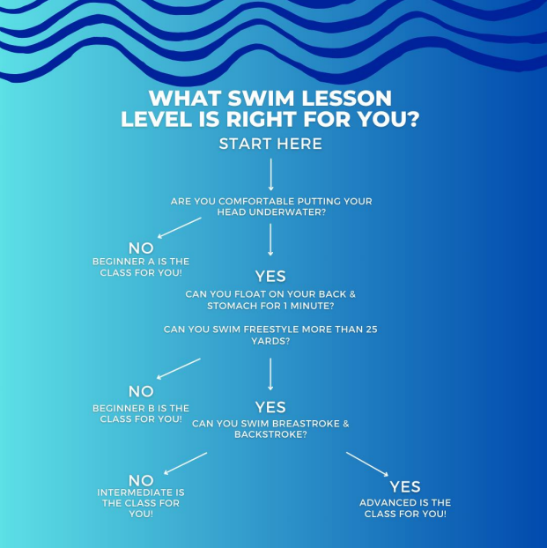

Classes Description -
Beginner -
This class is tailored to the individual with little to no swim experience and may be apprehensive about completely submerging. Instructors work closely with swimmers to increase water confidence by guiding them through the process of basic movement in the water. The goals of this class are to teach proper breathing while swimming and recovery to a standing position from the horizontal floating position.
Skills Learned:
Front crawl, elementary backstroke, breath control, submerging, rhythmic breathing, floating (on front/back), recovering from floating position.

Intermediate -
Are you confident being in the water and ready to become a stronger swimmer? This class will improve stroke proficiency while increasing your endurance in the water. Participants will learn the basics of all six swimming strokes. Our instructors will provide you with the skill set to add swimming to your exercise plan.
Skills Learned:
Rotary breathing, 50-yard Freestyle swim, Elementary Backstroke, Breaststroke, Butterfly, Back Crawl, Sidestroke, treading water

Advanced -
Take your workout to the next level! Maximize your fitness potential by adding another dimension to your water workout with stroke refinement of Backstroke, Breaststroke, Butterfly, and even flip turns! Sign up to work closely with a certified swimming instructor. This class is available to participants who are comfortable with rotary breathing and can swim at least one stroke for 50 yards without stopping. Individualized stroke refinement is offered during this session with feedback given to improve overall stroke performance..
Skills Learned:
Refinement of: Backstroke, Breaststroke, and Butterfly. Flip Turns, Swim etiquette, basics of writing a swimming workout, introduction to interval training in the water, drills for improving technique

Where do I park?
- Lessons take place at Florida Pool, attached to the Student Recreation and Fitness Center or the O'Connell Center Pool down the ramp of Gate 3
  - Florida Pool: Enter through the east main entrance, which can be accessed by walking through the Student Recreation and Fitness Center.
  - O’Connell Center Pool: Enter through the ramp next to Gate 3. Enter through the doors that say “Florida Swimming.”
- Please refer to UF Parking Services and attachment to determine the best location for you to park. Parking restrictions are in effect in some areas near to the pool.
  - The closest parking is located by the Stephen C. O’Connell Center.
  - Rec Sports is not responsible for any parking tickets you may receive.
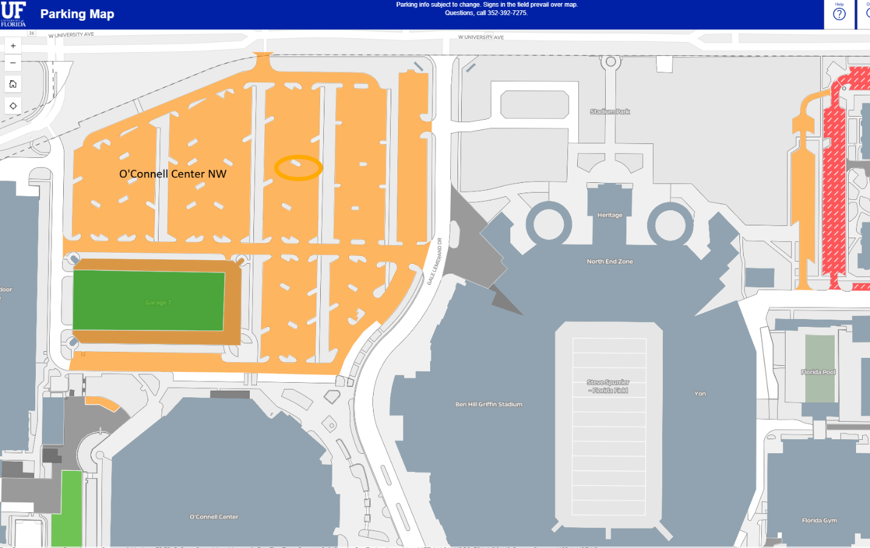

When are swim lessons held at O’Connell Center Pool?
- Lessons will be at O’Dome during the Fall and Spring Semesters.

